**Himanshi Bande G.H Raisoni College of Engineering, Nagpur CSE-AI – 06 NLP – TAE2**

**Topic : AI-Powered Resume Screening System Using NLP**

**\*Abstract\***

The traditional resume screening process is time-consuming and prone to human biases, leading to inefficiencies in recruitment. With the advancements in Artificial Intelligence (AI) and Natural Language Processing (NLP), automated resume screening systems have gained significant attention. This review paper explores the role of NLP-based AI systems in streamlining resume screening, discusses existing methodologies, evaluates their performance, and identifies challenges and future research directions.

**\*1. Introduction\***

Recruitment is a crucial function in human resource management, and resume screening is a key step in shortlisting candidates. However, manual screening of resumes is labor-intensive and subjective. AI-powered systems, particularly those leveraging NLP, offer automated solutions that can process large volumes of resumes efficiently and fairly. This paper reviews the development, methodologies, and challenges associated with AI-driven resume screening systems.

**\*2. NLP Techniques in Resume Screening\***

NLP is at the core of AI-powered resume screening systems, enabling automated parsing, keyword extraction, semantic analysis, and ranking. Some key NLP techniques used include:

- *Named Entity Recognition (NER):* Identifies names, skills, and job titles.

- *Text Classification:* Categorizes resumes based on relevant job roles.

- *Sentiment Analysis:* Assesses soft skills and personality traits.

- *Word Embeddings (Word2Vec, BERT, FastText):* Captures contextual meaning for better understanding.

**\*3. Existing AI-Powered Resume Screening Systems\***

Several AI models and frameworks have been developed to enhance resume screening:

- *Rule-based Systems:* Utilize predefined keyword matching but lack contextual understanding.

- *Machine Learning Models:* Supervised learning models such as SVM, Decision Trees, and Random Forests improve classification accuracy.

- *Deep Learning Models:* CNNs, RNNs, and Transformer-based models (BERT, GPT) enhance text comprehension and ranking.

- *Hybrid Approaches:* Combine rule-based and deep learning techniques to improve accuracy.

**\*4. Performance Evaluation and Benchmarking\***

Evaluating AI-powered resume screening systems involves:

- *Accuracy and Precision:* Effectiveness in correctly categorizing candidates.

- *Recall and F1-score:* Measuring the system's ability to retrieve relevant resumes.

- *Fairness and Bias Mitigation:* Assessing how well the model avoids discrimination.

- *Scalability and Efficiency:* Performance in processing large datasets.

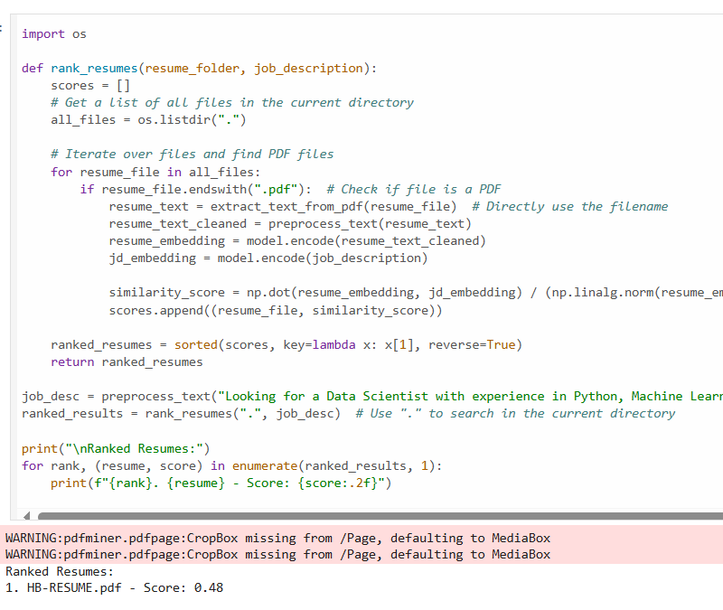

**\*5. Challenges and Limitations\***

Despite advancements, AI-powered resume screening systems face several challenges:

- *Data Bias and Fairness:* Bias in training data can lead to unfair hiring decisions.

- *Interpretability and Transparency:* Difficulty in understanding AI decisions.

- *Contextual Limitations:* NLP models struggle with nuanced resume interpretations.

- *Generalization Issues:* Models may not perform well across industries and job roles.

**\*6. Future Research Directions\***

To enhance the effectiveness of AI-powered resume screening, future research should focus on:

- *Bias Reduction Strategies:* Developing fair AI models with ethical AI practices.

- *Explainable AI (XAI):* Increasing transparency in decision-making.

- *Multimodal Analysis:* Integrating textual, visual, and behavioral data for better candidate assessment.

- *Industry-Specific Customization:* Adapting models for different domains.

**\*7. Conclusion\***

AI-powered resume screening systems leveraging NLP offer significant improvements over traditional methods by automating, optimizing, and enhancing the recruitment process. While these systems provide efficiency and scalability, addressing biases, improving interpretability, and ensuring fairness remain critical challenges. Continued research in AI and NLP will further refine resume screening methodologies, making recruitment more efficient and equitable.